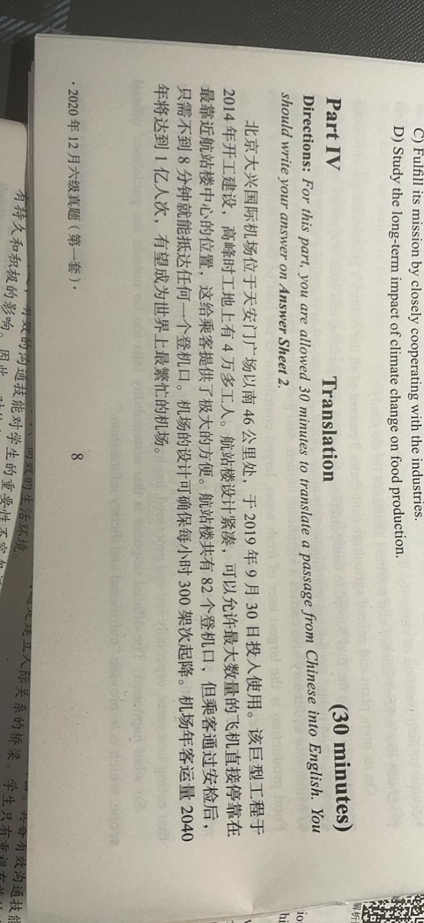

put , starting being used(being put into use) in(on) Sep 30th 2019. The great(giant) building program(construction) started constructing in 2014. There are more than 40 thousand builders on the scene(site) when it was in top time(at its peak). The buildings(terminal) were designed to be close with each other(compact), allowing the largest amount(maximum number) of planes to land directly in the place where it’s closest to the center of the building, which offers great convenience to the passengers. There are totally 82 accesses(boarding gate) to the airplanes in the building. However, after check in(security), passengers only spend less than 8 minutes to reach any of the access. The design of the airplane can guarantee 300 times of landing and taking off(landings and takeoffs) per hour. The annual amount of passengers (the airport can handle) will reach 100 million in 2040. It’s promising to be the busiest airplane in the world.